Group assignment :

Prepared by:

* Shiva srivastava
* Mohit sharma
* Tejaswani singh chauhan
* Dheeraj sharma

guided by: Jitesh Bhatia sir

***Solution:1)Objective : Create a table of mathematical formulae using entities of html***

Procedure:

<html>

<head>

<title>use of entities of html in formula writing </title>

<style>

table,td,th{border:2px red solid; border-collapse:collapse ;border-radius:2px; background-color:yellow; text-align:center;}</style>

</head>

<body>

<table style="width:90% ;height:60%">

<caption style="font-size:40px; color:gray;">Representation of Mathematical Formulae</caption>

<tr>

<th>s.no</th>

<th>Name of formula </th>

<th>symbolic formulae</th>

</tr>

<tr>

<td>1</td>

<td>Area of circle</td>

<td>&pi;r<sup>2</sup></td>

</tr>

<tr>

<td>2</td>

<td>Trigonometry formula </td>

<td>

<ol><li>1+tan<sup>2</sup>&theta;=sec<sup>2</sup>&theta;</li>

<li>sin<sup>2</sup>&theta;+cos<sup>2</sup>&theta;=1</li>

<li>1+cot<sup>2</sup>&theta;=cosec<sup>2</sup>&theta;</li>

</td>

</tr>

<tr>

<td>3</td>

<td> square of (a+b) </td>

<td>(a+b)<sup>2</sup>=a<sup>2</sup>+2ab+b<SUP>2</SUP></td>

</tr>

<tr>

<td>4</td>

<td> Cube of (a+b)</td>

<td>(a+b)<sup>3</sup>=a<sup>3</sup>+3a<sup>2</sup>b+3ab<sup>2</sup>+b<sup>3</sup></td></tr>

<tr>

<td>5</td>

<td>Difference between <br> square of two numbers </td>

<td>a<sup>2</sup>-b<sup>2</sup>=(a+b)(a-b)</td>

</tr>

<td>6</td>

<td>Time Period of a <br> pendulum</td>

<td>T=2&Pi;&radic;l&frasl;g</td></tr>

<tr><td>7</td>

<td>Gravitional Force</td>

<td>F=Gm<sub>1</sub>m<sub>2</sub>&frasl;r<sup>2</sup></td>

</tr>

<tr>

<td>8</td>

<td>Kinetic Energy</td>

<td>K<sub>e</sub>=1&frasl;2mv<sup>2</sup></td>

</tr><tr>

<td>9</td>

<td>Mass and energy <br>relation</td>

<td>E=mc<sup>2</sup></td></tr>

<tr>

<td>10</td>

<td>Relational between density (&rho;),<br>mass, and Volume. </td>

<td>&rho;=m&frasl;v</td>

</tr>

</table>

<blackquote style="color:red;">Formulae prepared by:<ol><li> Shiva Srivastava</li><li>Mohit sharma</li><li>Tejaswani singh</li><li>Dheeraj sharma</li></ol></blackquote>

</body>

</html>

Result:

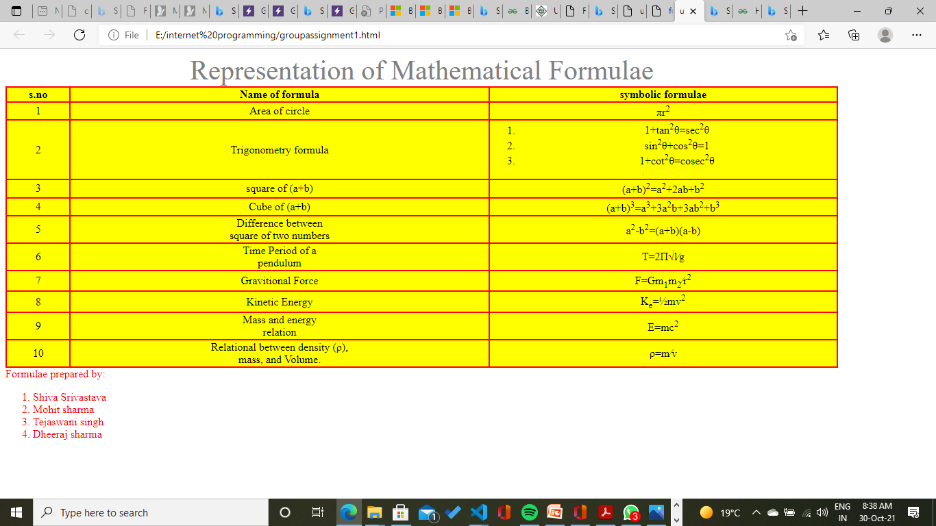

Conclusion:

From here we learn how to use symbol which are not given in keyboard

Solution:2)

Objrctive: to make a webpage which show the registration process of SMTD infotech

Procedure:

<html>

<head>

<title>shiva infotech pvt</title>

</head>

<body>

<div style="background-color:blue"><table align="center" ><tr><th><h2 align ="center"> SMTD Infotech </h2></tr></th><br><tr><th><h3 align="center">SMTD information technology PVT- bangalore ,east of Unacademy </h3></th></tr></table></div>

<form action="https://www.gla.ac.in" method="post">

<div style="background-color:yellow" align="center"><em><h1>Job Appllication form</h1></em></div>

<table width="100%"><tr><th><table style="border : black 0px solid;" align="left">

<tr><th colspan ="2">Sign in</th>

<tr><th><labeL for="username">Register username:</label></th><th><input type="text" name="username" id="username" min="3" max="20" required></th></tr>

<tr><th><labeL for="password">Password:</label></th><th><input type="password" name="password" id="password" min="3" max="10" required></th></tr>

<tr><th><labeL for="confirm password">Confirm Password:</label></th><th><input type="password" name="confirm password" id=" confirm password" min="3" max="10" required></th></tr>

<tr><th colspan ="2" align ="center"><input type="button" name="button1" value ="continue"></th></tr></th></table>

<th ><table style="border:0px solid black;" align="right" ><tr><th colspan="2">Sign up</th></tr>

<tr><th><label for="resgistration">Register Email: </label></th> <th> <input type ="email" name="registration" id ="registration" min="10" max "50" required></th></tr>

<tr><th><label for ="enter password">Enter Password:</label></th><th><input type="password" id ="enter password" name="enter password" min="3' max ="10" required></th></tr>

<tr><th><label for ="renter password">Renter Password:</label></th><th><input type="password" id ="renter password" name="renter password" min="3" max="10" required></th></tr>

<tr><th colspan ="2"><input type="button" name="button2" value ="continue"></th></tr></th></table>

</table><br><br>

<br>

It is important that you read the guidance notes before completing this apllication form. Please complete this form fully using correct order and precision. Application must be submited within the 2 days of registration otherwise application will get canceled automatiaclly.<br>

<div style="background-color:gray;">

<h2><b>THIS INFORMATION YOU SYPPLY ON THIS FORMWILL BE TREATED IN CONFIDENCE.<b></h2></div>

<div style="background-color:yellow;" >

<h2 align="left"><b>Personal details:<b></h2></div>

<table style="border:0px solid black;" width="100%"><tr><th><table align="left"><tr><th><label for="first">First Name:</label></th><th><input type ="text" name ="first" id="first" required></th></tr>

<tr><th><label for ="gender">Gender:</label></th><th><label for ="gender">Male:</label><input type= "radio" name ="gender" id ="gender" ><br><label for ="gender">Female:</label><input type="radio" name="gender" id ="gender" required> </th></tr>

<tr><th><label for="language">Language known:</label></th>

<th><input list="language" required>

<datalist id="language">

<option value="English">

<option value="Hindi">

<option value="Urdu">

<option value="sankrit">

<option value="french">

</datalist></th>

</table></th>

<th><table align="right"><tr><th><label for="last">Last Name:</label></th><th><input type="text" name="last" reqired></th></tr>

<tr><th><label for ="religion">Religion:</label></th><th><label for ="religion">Hindu:</label><input type="radio" id="religion" name="religion"><br>

<label for ="religion">Others:</label><input type="radio" id="gender" name="religion" required></th></tr>

<tr><th> <label for="preffered">Preferred <abbr title="Programming Language">PL:</abbr></label></th>

<th><input list="preffered" required>

<datalist id="preffered">

<option value="C++">

<option value="Java">

<option value="Python">

<option value="Ruby">

</datalist></th>

</tr>

</table></th></tr></table>

<label for ="qualification">Highest Qualification:</label> <input type="text" name ="highest" id= "highest" required><br><br>

<label for ="mobile">Mobile:</label> <input type="tel" placeholder="0123456789" pattern="[0-9]{10}" required><br><br>

<label for ="tell about yourself"><textarea name="youself" rows="5" cols="100">Tell about Yourself</textarea><br><br>

<input type="submit" value="Submit" >

<input type="reset" Value="Reset">

</form>

<div style="background-color:yellow;"><blockquote align ="left">www.smdkinfotech.com</blockquote></div>

</body>

</html>

Result: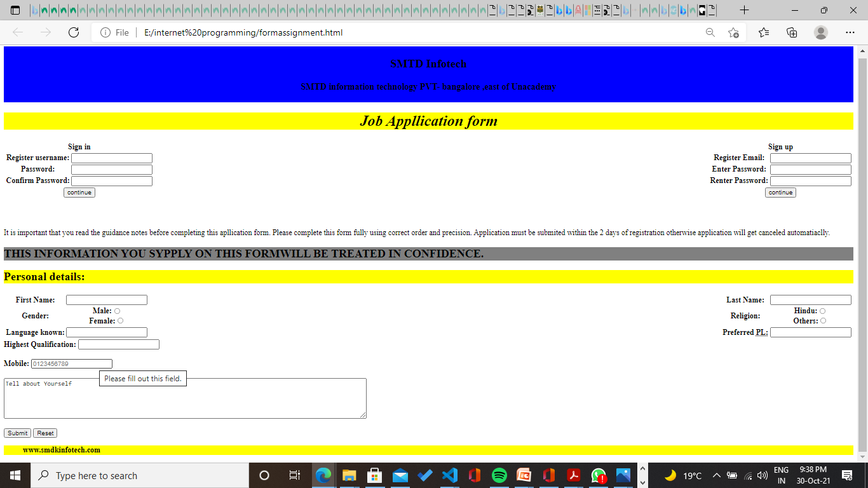

Conclusion: from this we learn how to use css , table and form simultaneously